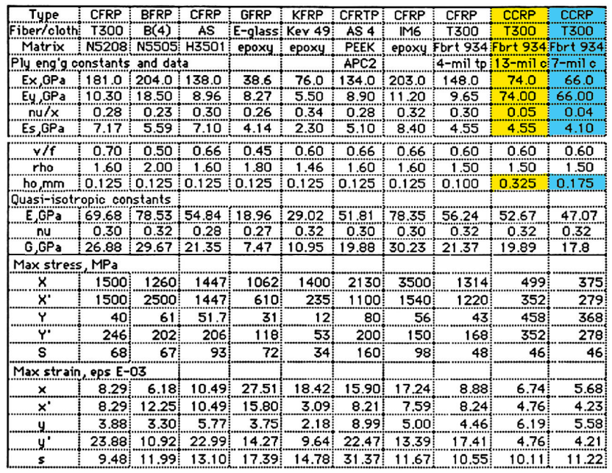

1. CCRP, T300, Fbrt 934, 13-mil c - 3 strati - t = 0.975 mm
2. CCRP, T300, Fbrt 934, 13-mil c - 2 strati - t = 0.650 mm
3. CCRP, T300, Fbrt 934, 7-mil c - 5 strati - t = 0.875 mm
4. CCRP, T300, Fbrt 934, 7-mil c - 6 strati - t = 1.05 mm